INTERGALACTIC SPACE TRAVEL REQUEST SYSTEM

ISTR — Final Documentation
End-to-End Solution Documentation

7  Functional Reqs FR-1 to FR-7 | 15  User Stories | 3  Sprints | 13  Velocity Story Pts / Sprint | 100%  Test Pass Rate 21/21 cases

Date | 12/09/2026
Student Name | Navya Sri Tangellamudi
Project Name | Intergalactic Space Travel Request System (ISTR)
Application Scope | Intergalactic Space Travel Request System (Scoped Application)
Platform | ServiceNow — Scoped Application
Document Status | Final — Ready for Evaluation

Introduction

Project Overview
The Intergalactic Space Travel Request (ISTR) System is a ServiceNow scoped application that automates the full lifecycle of a space mission request — from submission through multi-level approval (Manager, Finance, and risk-based Mission Control review) to launch execution and audit. This document consolidates the requirements, design, sprint delivery, and the actual working build into a single end-to-end record of the project, including screenshots of the live scoped application.

Purpose
Mission-eligible staff (Scientists, Diplomats, and other personnel) need a reliable, auditable way to request approval for intergalactic travel. Manually coordinating sign-off across a Manager, Finance, and — for higher-risk missions — Mission Control is slow and opaque, with no consistent visibility into where a request stands or why it was rejected. ISTR replaces this ad-hoc process with a structured, rule-based workflow inside ServiceNow.

Ideation Phase

Problem Statement
How might we streamline and automate the end-to-end approval process for intergalactic mission requests, so that Managers, Finance, and Mission Control can review, approve, and launch missions quickly, securely, and with full transparency?

Empathy Map Canvas
The Requester — a mission crew member who submits space travel requests — is the primary persona. Empathy mapping surfaced a consistent theme across all five stakeholder roles: every frustration traces back to the lack of a connected, automated system of record.

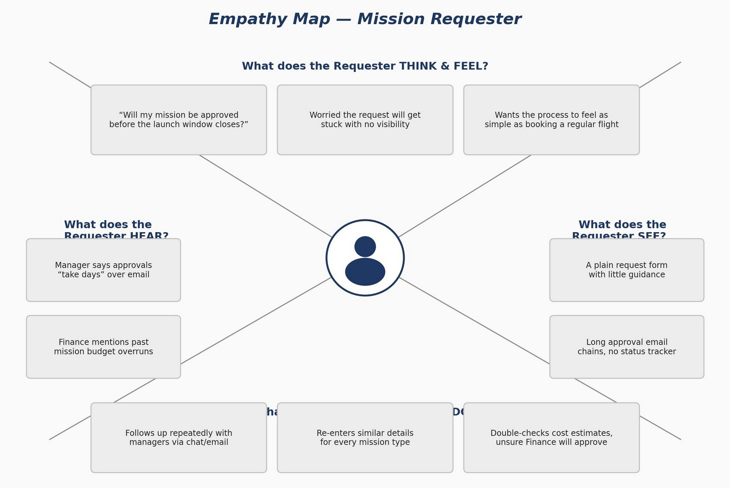
Figure 1: Empathy Map — Mission Requester

Rating each role's pain intensity confirmed where design priority was highest: Requesters, Managers, and Mission Control all rated 4/5 (pain that directly blocks mission progress), while Finance and Admin rated 3/5 (pain rooted in data quality and long-term trust rather than moment-to-moment blockage).
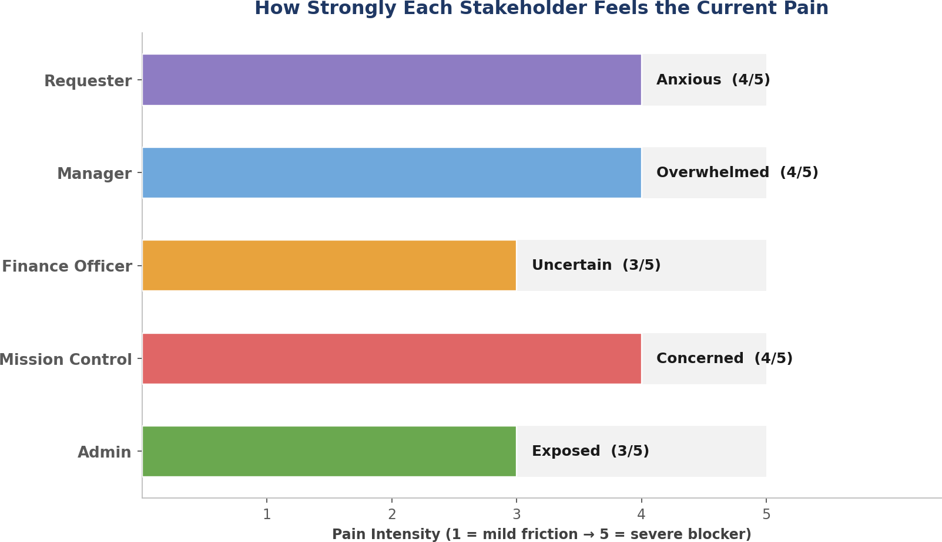
Figure 2: Pain Intensity Across ISTR Stakeholder Roles

Brainstorming
The team generated ten concrete ideas across four themes — Workflow Automation, Security & Access Control, User Experience, and SLA/Notifications/Audit — then prioritized each by Importance and Feasibility. The custom table, roles/groups, and core approval flow landed as Quick Wins and Major Projects and became the backbone of the build; AI-driven risk assessment was consciously deferred to a future release.
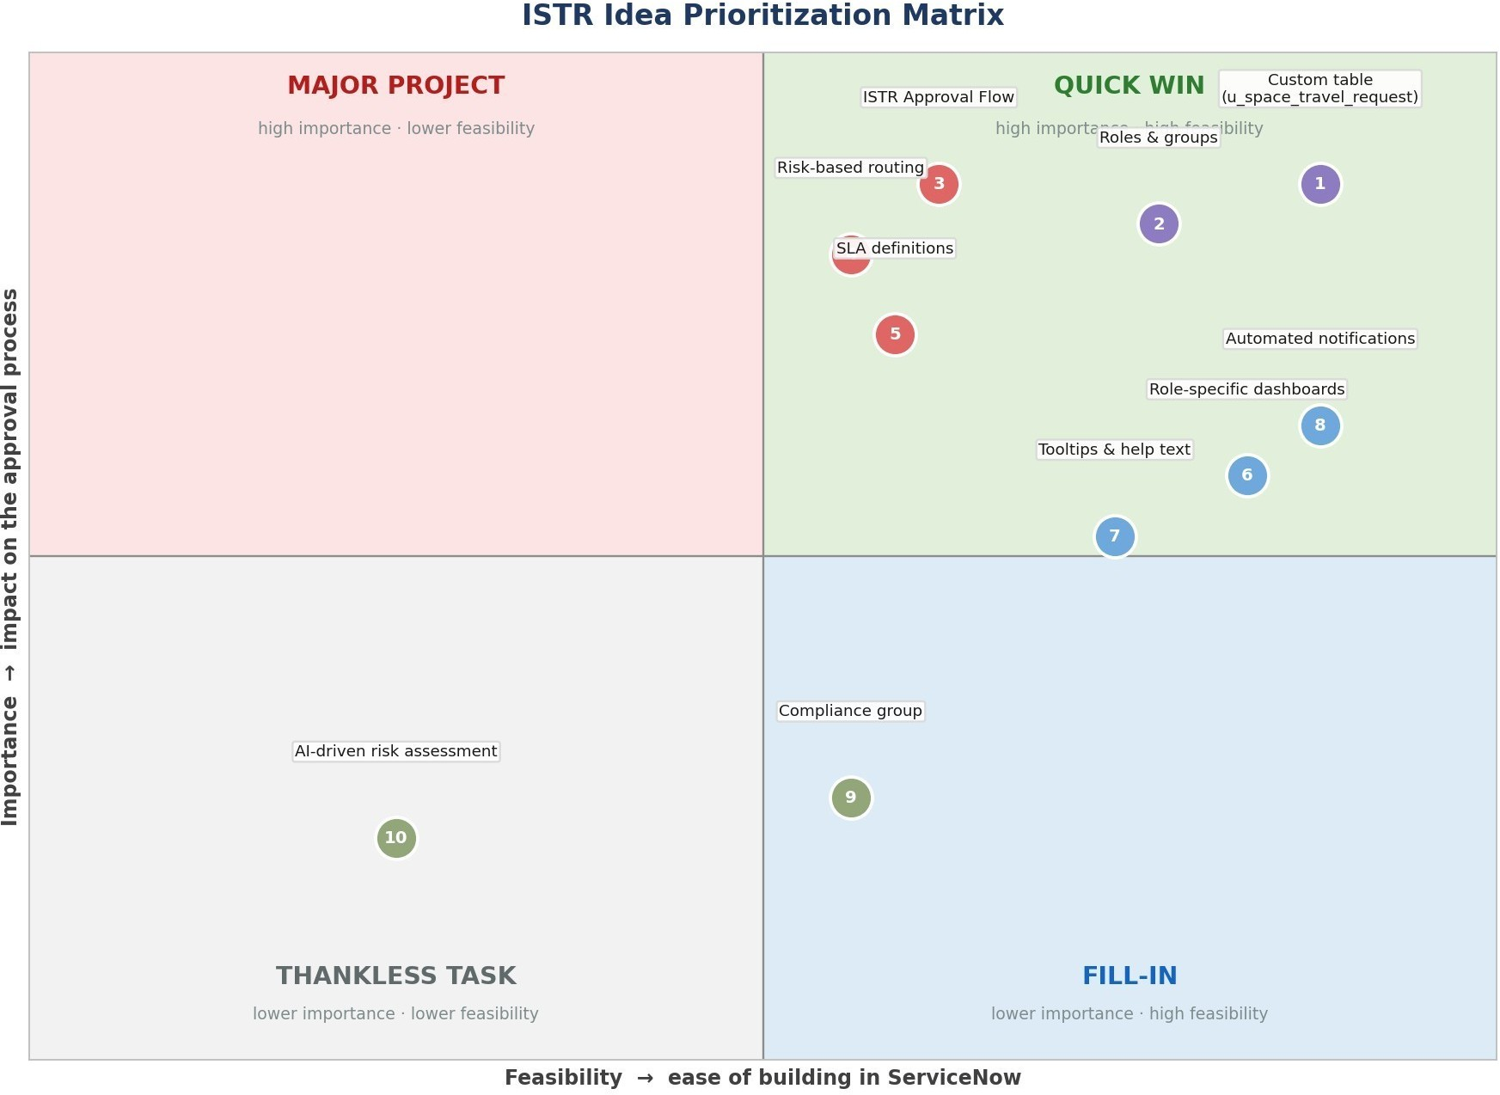
Figure 3: ISTR Idea Prioritization Matrix

Requirement Analysis

Customer Journey Map
The journey traces how a mission request moves from trigger to outcome — from a new mission or launch window prompting the Requester to act, through today's manual chasing across portal/email/briefings, to ISTR's automated routing and a confident, fully audited outcome.

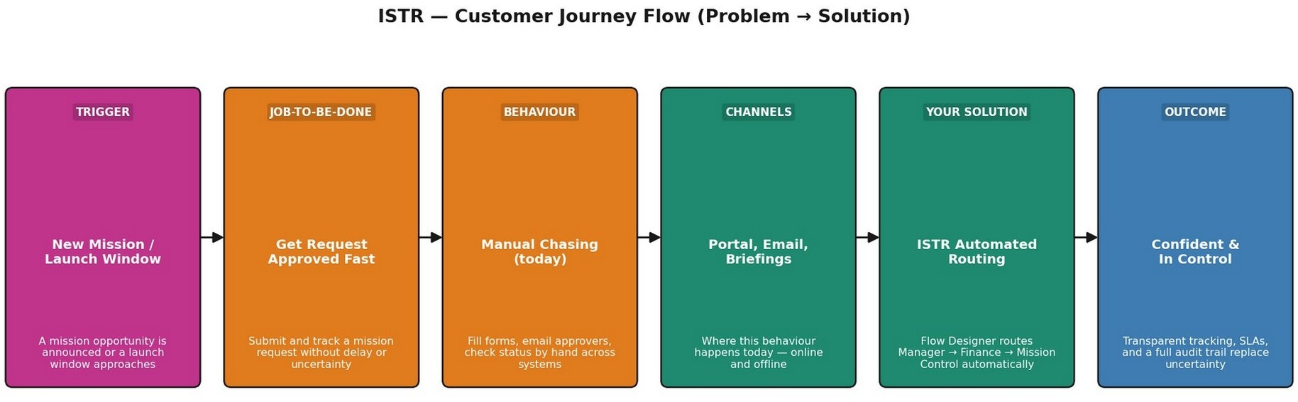

Figure 4: ISTR Customer Journey Flow (Problem → Solution)

Solution Requirement
Seven functional requirement epics (Mission Request Submission, Request Confirmation, Approval Routing, Role-Based Access Control, SLA & Escalation Management, Launch Execution, and Audit Trail & Reporting) define the system scope, backed by non-functional requirements covering usability, security, reliability, performance, availability, scalability, and auditability.

Data Flow Diagram
The Level 0 DFD shows how a mission request enters the system from the Requester, moves through automated approval routing (Manager, Finance, and conditionally Mission Control), is written to the request table and audit/SLA log, and results in a launch action and stakeholder notifications.
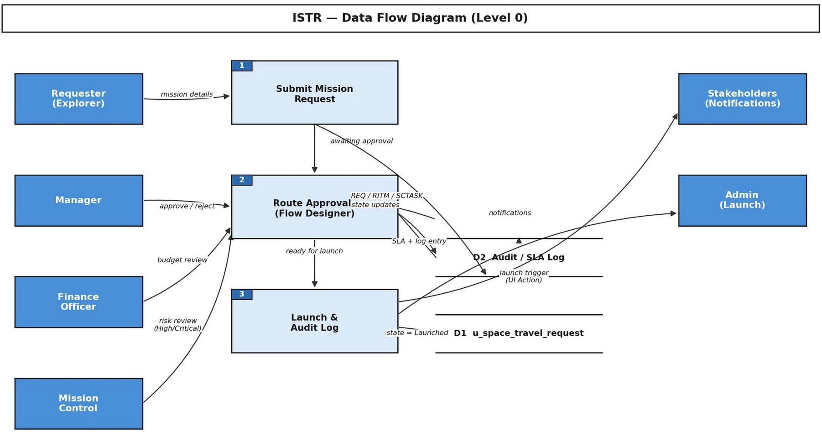

Figure 5: ISTR Data Flow Diagram (Level 0)

Technology Stack
ISTR is built entirely on native ServiceNow capabilities — a custom table, Flow Designer for orchestration, an ACL/role engine for security, an SLA engine for escalation, and Update Sets for Dev/Test/Prod promotion — with no unsupported third-party dependency for v1.0.
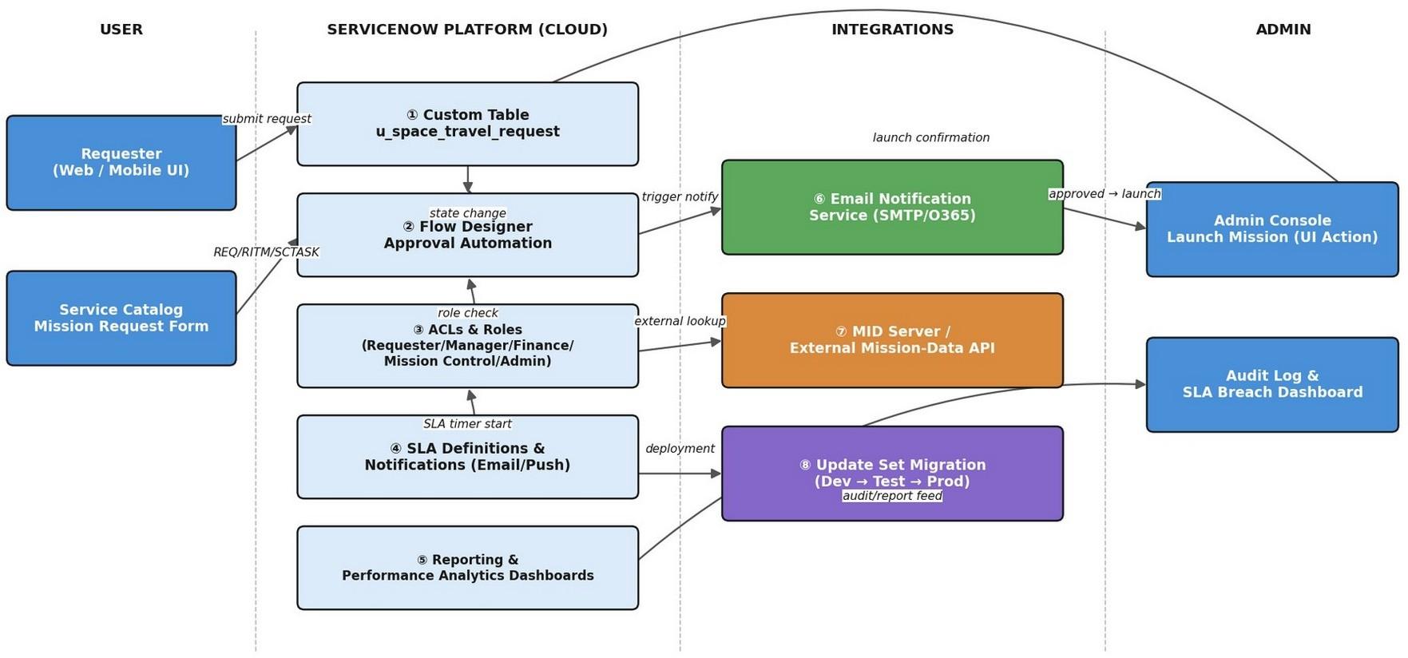

Figure 6: ISTR Technical Architecture

Project Design

Problem Solution Fit
Problem-Solution Fit confirmed that the mission-approval problems faced by Requesters, Managers, Finance Officers, and Mission Control are real, and that ISTR's automated routing, RBAC, and audit trail genuinely solve them — validated across all ten dimensions of the Problem-Solution Fit Canvas.

Proposed Solution
The proposed solution maps the problem statement directly to ISTR's design: a ServiceNow scoped app on a custom table with Flow Designer conditional routing, differentiated by risk-based escalation and SLA-driven automation, delivering faster and more trustworthy approvals with a scalable, modular architecture.

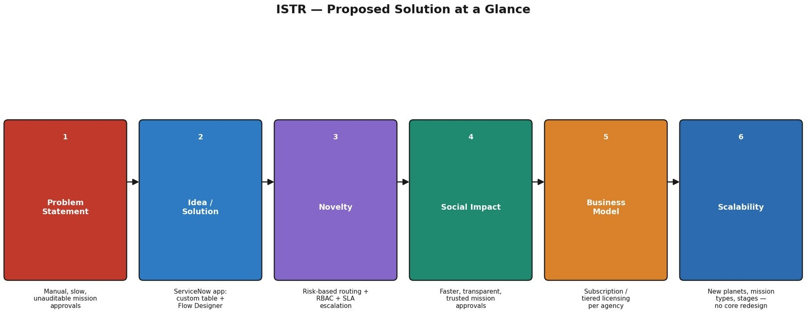
Figure 7: ISTR Proposed Solution at a Glance

Solution Architecture
ISTR is built as its own scoped application — Intergalactic Space Travel Request System — rather than in the Global scope, isolating its table, flow, and roles from the rest of the instance. The custom table x_2065326_interg_0_space_travel_request stores every mission request; the ISTR Approval Flow (Flow Designer) orchestrates the approval chain; and role-based access control governs who can see and act on each record.
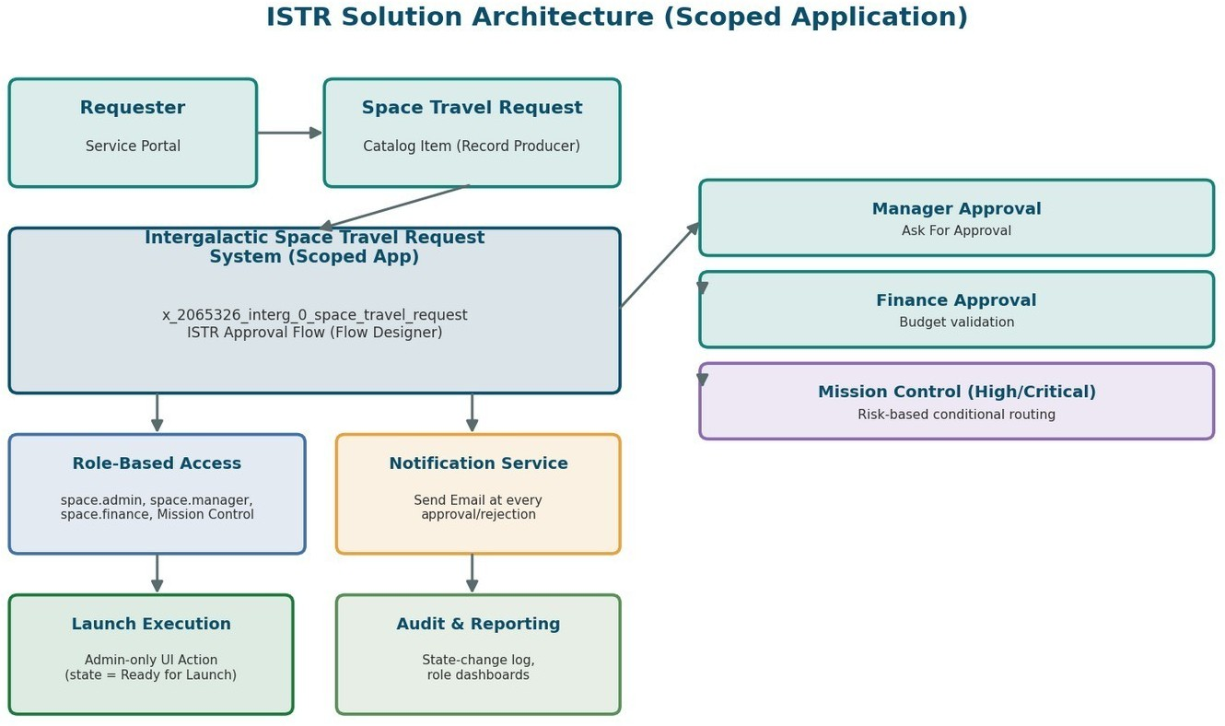

Figure 8: ISTR Solution Architecture (Scoped Application)

Data Model
The Space Travel Request table captures everything needed to process a mission end to end: destination, mission type, risk level, cost, launch date, the assigned Diplomatic Officer (for Alien Negotiation missions), manager, state, and Mission Control notes.

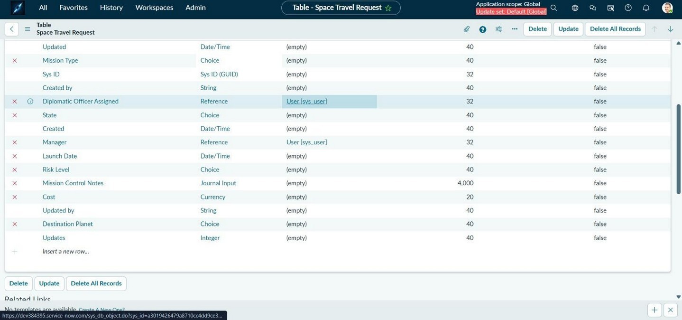
Figure 9: Space Travel Request Table Schema

Approval Workflow — ISTR Approval Flow
The ISTR Approval Flow is the heart of the system, built and Active in the scoped application. On record creation, it looks up the requester, routes to their Manager, then to Finance for budget validation, and — only for High/Critical risk missions — on to Mission Control. Every approval or rejection at any stage triggers a Send Email notification back to the requester.
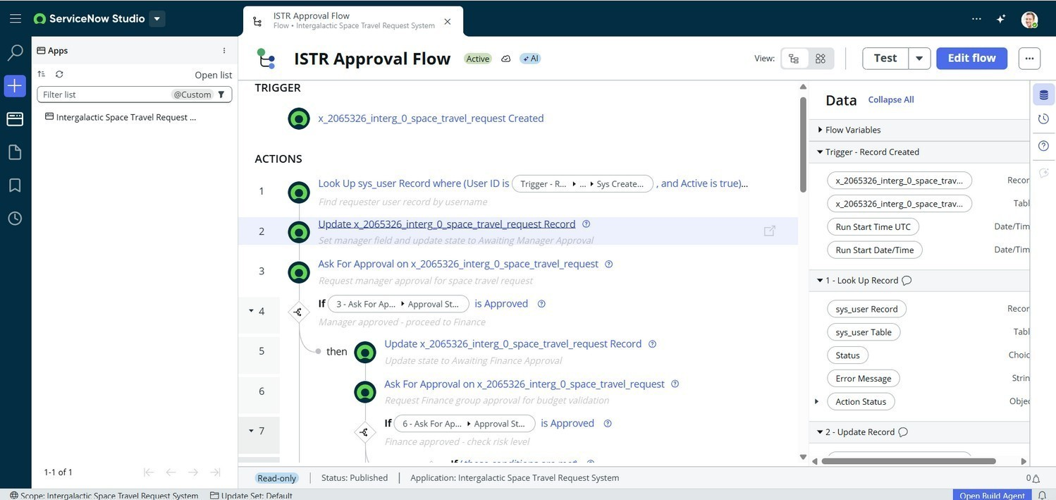
Figure 10: ISTR Approval Flow — Trigger and Core Action Chain

The risk-based branch shows the conditional split: High/Critical missions route to Mission Control before launch readiness, while Low/Medium risk missions are approved directly once Finance signs off — keeping the process fast for routine requests without skipping oversight on higher-risk ones.

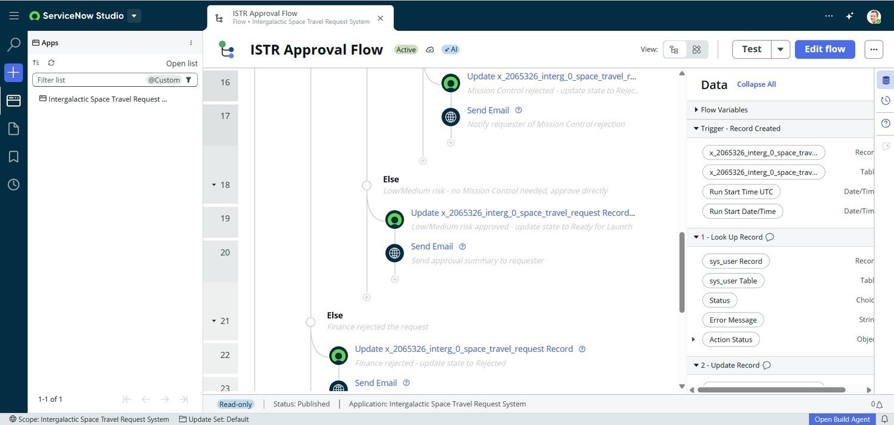
Figure 11: Risk-Based Routing — Mission Control vs. Direct Approval

Role-Based Access Control
Access is governed by dedicated roles and groups rather than broad platform access. The space.admin role, for example, is scoped to administrators with full access to mission records, configuration, and system management
— everyone else sees only what their role requires.
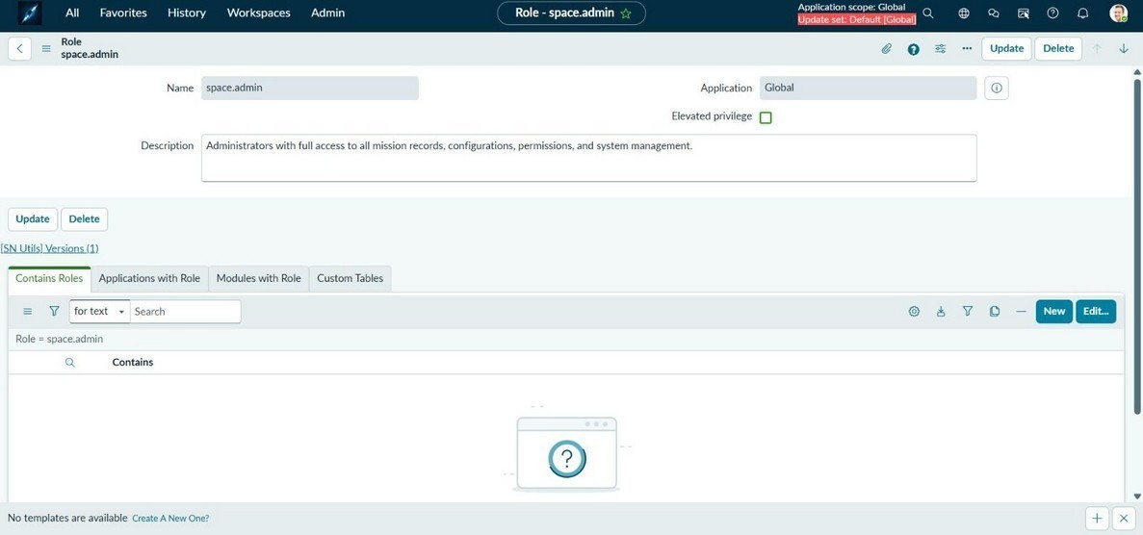
Figure 12: space.admin Role Definition

Stakeholder groups mirror the approval chain directly: Explorers (requesters), Finance (budget validation), and Mission Control (risk review) each exist as their own group, so Flow Designer's approval routing and every ACL resolve against real, purpose-built groups rather than ad-hoc user lists.

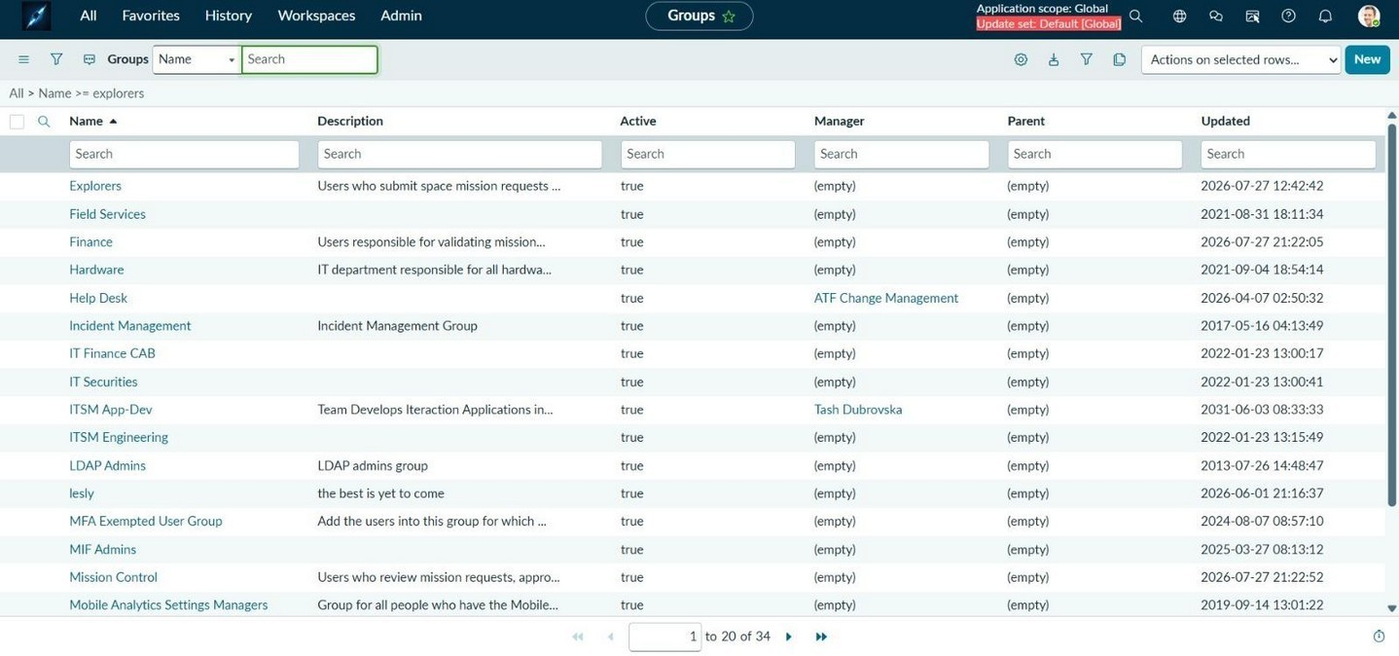
Figure 13: ISTR Stakeholder Groups (Explorers, Finance, Mission Control)

User Experience — Service Catalog
Requesters submit missions through a dedicated Service Catalog item, Space Travel Request, presented with mission-appropriate imagery and a form covering destination, risk level, mission type, cost, and launch date — the same fields defined in the data model above.
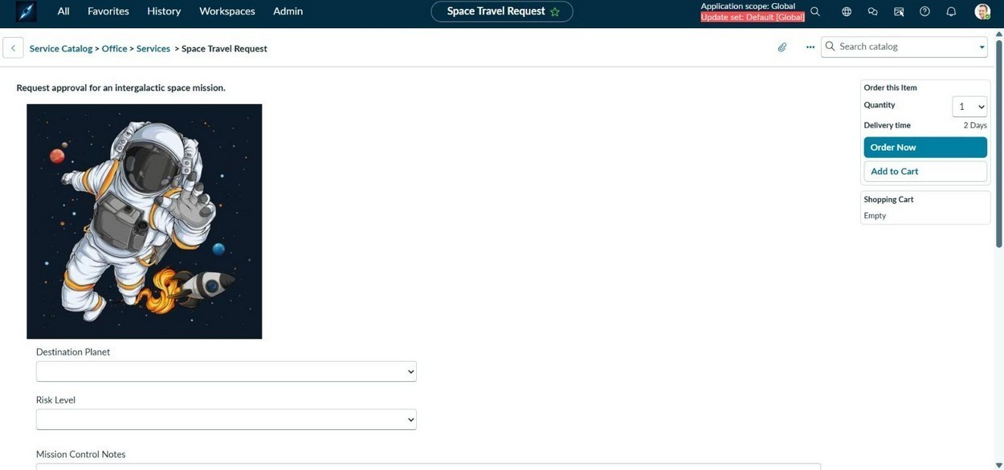
Figure 14: Space Travel Request Catalog Item

Project Planning & Scheduling

Project Planning
ISTR's 15 user stories were delivered across 3 sprints, front-loading the core submission-to-approval path in Sprint-1 before layering on tracking, risk review, launch, and reporting. The team's measured velocity of 13 story points per sprint held consistent throughout delivery.

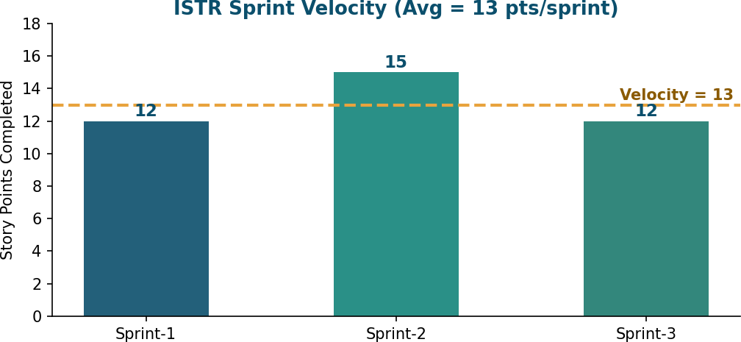

Figure 15: ISTR Sprint Velocity

Functional and Performance Testing

Performance Testing
Full functional, performance, and User Acceptance Testing was already completed and documented in the Functional & Performance Testing and User Acceptance Testing phases of this project. This section summarizes those results rather than repeating the full test-case tables: every executed test case passed — 21 of 21 — covering both positive scenarios (valid submissions, correct routing) and negative ones (blocked invalid input, denied unauthorized access).
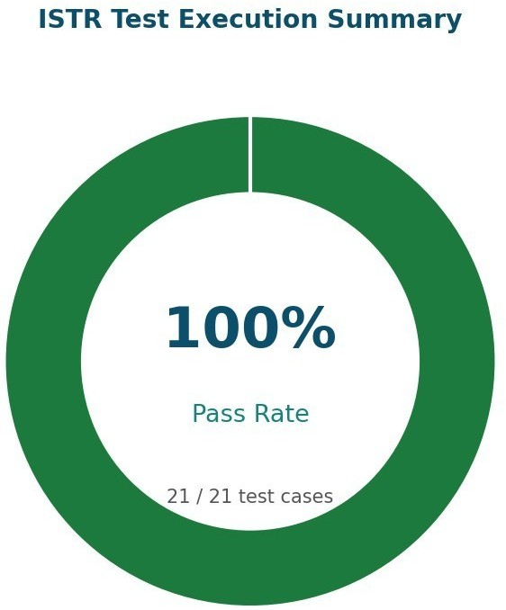

Figure 16: Overall Test Pass Rate (21/21 test cases)

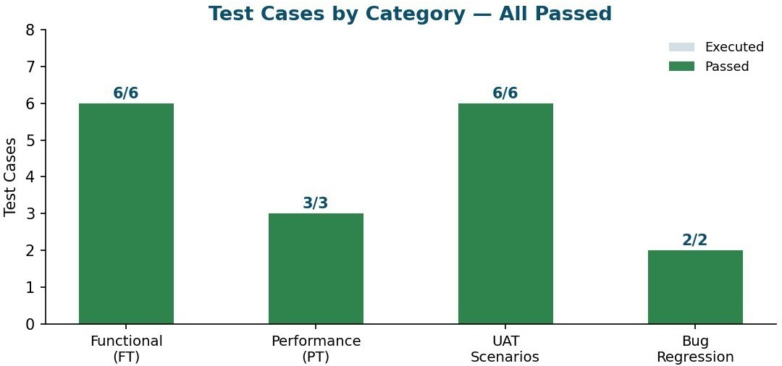

Figure 17: Test Cases by Category

    - 2 bugs were found and closed during UAT (a UI Policy field-visibility issue and a duplicate notification trigger) — both fixed and verified before sign-off.
    - No open defects remained at the time of this report; the application was signed off as ready for evaluation.

Results

Output Screenshots
The screenshots below are taken directly from a live run of the scoped application — not mockups. Request REQ0010002 was submitted, routed through the approval chain, and reached Approved state, confirming the Flow Designer logic executes correctly end to end.
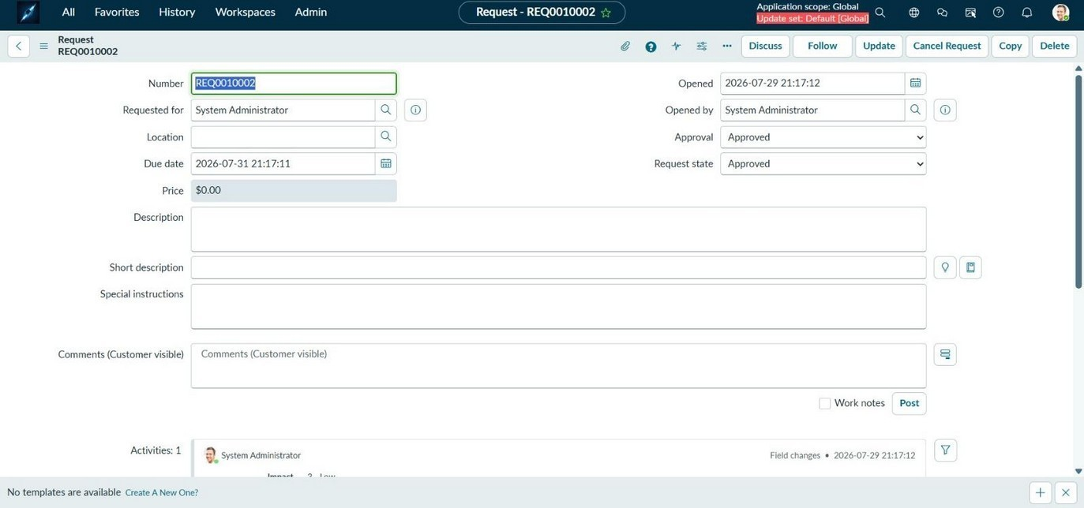
Figure 18: Request REQ0010002 — Approval = Approved, Request State = Approved

The underlying Requested Item (RITM0010002) shows real mission data flowing through the record — including the Diplomatic Officer Assigned field populating correctly for the mission, and cost and risk level captured as entered.
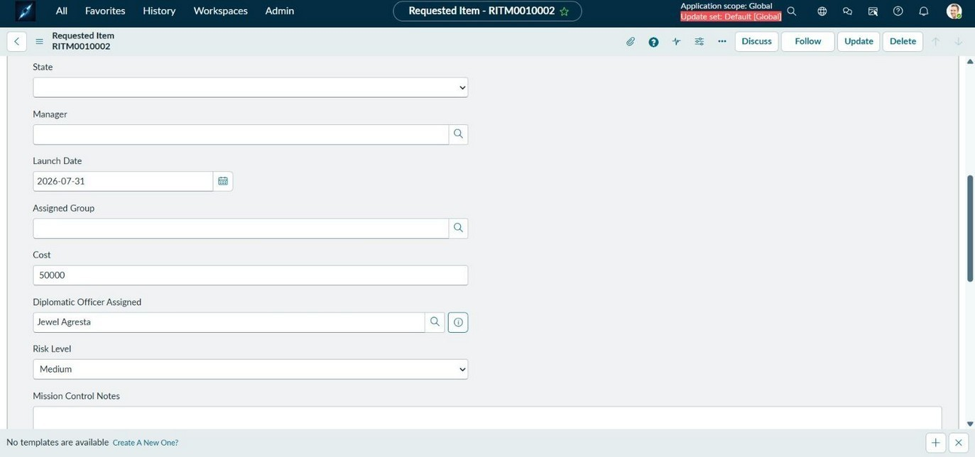
Figure 19: RITM0010002 with Populated Mission Data

Approval also drives downstream orchestration: catalog tasks were automatically generated and assigned to the Field Services and Software groups, demonstrating that ISTR doesn't just track approval state — it fans out the resulting work.
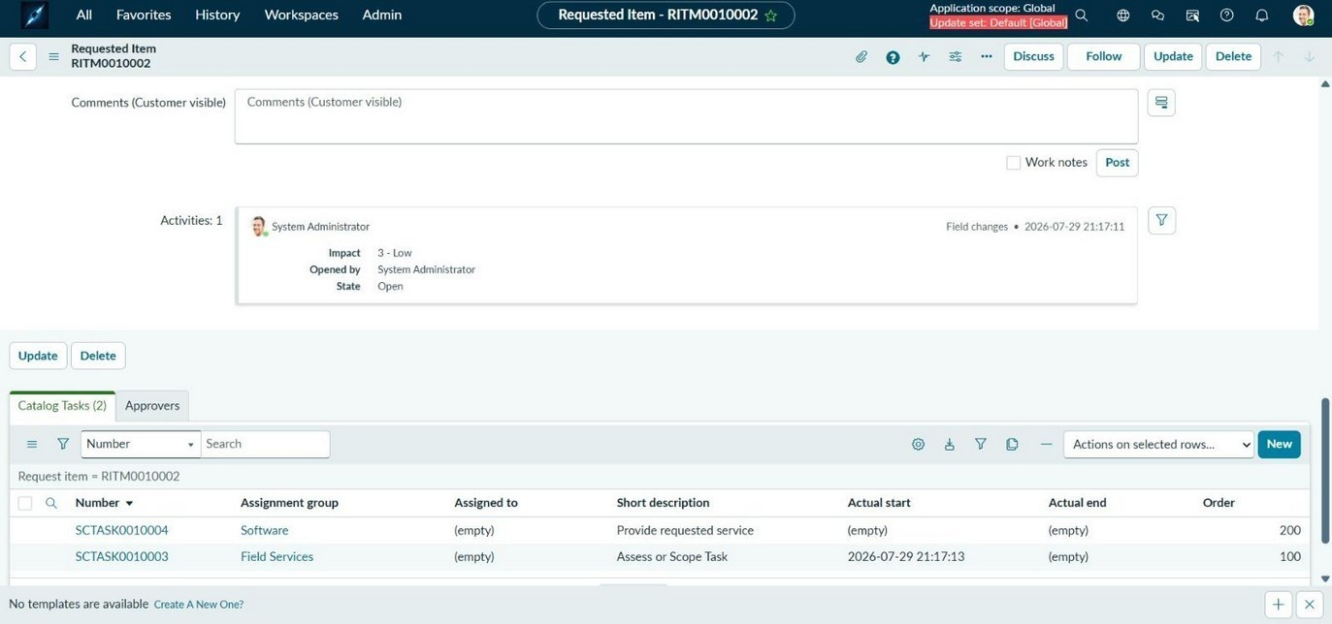
Figure 20: Auto-Generated Catalog Tasks (SCTASK0010003, SCTASK0010004)

Advantages & Disadvantages

Advantages
- Cuts mission-approval turnaround from days to hours by removing manual chasing across email and spreadsheets.

- Risk-based conditional routing means Mission Control only engages when a mission's risk actually justifies it.
- Full, tamper-evident audit trail supports compliance review and post-mission accountability.
- Fine-grained, role-driven security keeps sensitive mission data visible only to the stakeholders who need it — verified directly through the space.admin role and stakeholder groups shown above.
- Modular custom-table and Flow Designer design absorbs new planets, mission types, and approval stages without a core redesign.
- Verified end to end on live data — from catalog submission through Approved state to auto-generated fulfillment tasks — not just in theory.

Disadvantages
- v1.0 scope excludes advanced analytics and external mission-control integrations, so some reporting is still manual.
- Depends on accurate risk classification at submission — a mis-tagged request could under-route and skip Mission Control review.
- Built specifically on ServiceNow, so adopting it requires an existing or new ServiceNow instance rather than being platform-agnostic.
- Multi-agency approval support is not yet included, limiting cross-agency joint-mission scenarios in this release.

Conclusion

ISTR successfully translates a manual, opaque mission-approval process into a structured, auditable ServiceNow application. The scoped-application build, its Active approval flow, and the verified end-to-end request lifecycle demonstrate that the system meets the functional and non-functional requirements defined in the design phase, delivered on schedule against the sprint plan, and passed testing without any open defects.

Future Scope

- Expand to multi-agency approval support as adoption grows across allied space agencies.
- Add predictive risk-scoring using Predictive Intelligence to reduce dependency on manually entered risk levels.
- Introduce advanced analytics and dashboard reporting beyond the current audit-log view.
- Integrate with external mission-control platforms and third-party mission-data APIs.
- License ISTR to allied agencies once proven on a home instance, supporting a shared, auditable approval standard across organizational boundaries.

